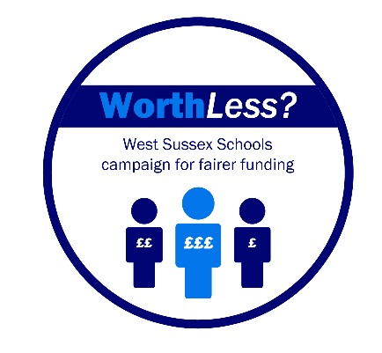
8 November 2016

Dear Parent/Carer

Worth Less? Update – November 2016

Thank you for your continuing support for Worth Less? and our campaign to gain transitional funding of £20m beginning in the financial year, April 2017.

Our collaborative efforts have allowed the dire financial situation of schools across West Sussex to be fully appreciated and understood. Whilst a new National Funding Formula could, and should make things better for the future, it simply will not solve our current financial crisis. The facts are now well known and accepted by decision makers. Primary schools are being run on a shoestring and budget forecasts for secondary and special schools are showing projected shortfalls of hundreds of thousands of pounds.

Your children’s schools cannot afford to employ adequate numbers of staff and even the most basic services such as books and IT equipment are proving to be out of reach.

In a recent parliamentary debate, initiated by local MPs, our plight was effectively highlighted to representatives from the DfE; we are grateful for this intervention.

The fundamental issue remains, however, that despite expressions of concern by Headteachers, local representatives/MPs and the media, no interim funding has yet been offered by the DfE. We are concerned that our legitimate and reasonable requests are falling on deaf ears.

In a letter to a local Headteacher, dated 2 November 2016, Nick Gibb MP (Minister for Schools) wrote “In 2015-16 we made a step towards fairer funding by adding £390m to the schools budget, targeted at the least fairly funded authorities, including West Sussex. The additional funding for West Sussex was included in their baseline in 2016-17 and is protected for 2017-18.” Headteachers are dismayed that the Minister is still trying to allay our fears by writing in such terms. Of the £390m, West Sussex schools received less than £1m (£930k). This represented an increase of less than £10 per child across West Sussex.

Mr Gibb also states that “In the interim, we believe that it is important that schools and local authorities have the information they need to plan ahead and we have now confirmed arrangement for 2017-18.” Frankly, all this tells us is what we have known for some time, that current funding for West Sussex school children is wholly inadequate.

Without £20m interim funding, the highly undesirable options that we are now actively planning for – increased teacher/pupil ratios, modified opening hours and reductions in basic services such as cleaning – look increasingly likely.

School Leaders are perplexed as to why an interim settlement cannot be found as we await the introduction of a new National Funding Formula. At the start of the year £500m was made available for a wholesale acadamisation programme. Last week, this policy was scrapped, and we are struggling to understand why the newly available funds cannot be reallocated.

Further, if the DfE chose to reduce the average London borough per pupil funding by £100 - from £6,000 to £5,900 - funding totalling hundreds of millions of pounds would be generated. Again, part of this could be reallocated to West Sussex schools and academies.

£20m of interim funding represents just a £200 per pupil increase for our students. If this were to happen, our budget crisis would be temporarily resolved, yet West Sussex children would still only receive £4,400 each – a sum of £200 per pupil below the national average and £1,500 per pupil below the average London borough. However, this sum would benefit your children enormously.

On 18 and 24 November, primary and secondary school leaders are holding emergency meetings to look at the ‘next steps’ for our interim funding campaign. We will be liaising with two local MPs to confirm follow up actions. It is likely that we will be calling for your direct support in the future too.

We are extremely sorry to have to send out such negative information but we do wish to keep you informed of the situation and our ongoing frustrations. It is important that you understand the position that schools are in and why this campaign is so important. An interim funding arrangement would immediately alleviate the significant issues that children, schools and their families face in West Sussex.

Yours faithfully

