

Fire & Ice
We hope you had a lovely Summer holiday and we are looking forward to teaching your child in Year 1 and 2. We will be working hard over the next few weeks to ensure that all the children are settled and happy in their new classes. If you have any concerns please do come and speak to your class teacher.

This term our topic is ‘Fire and Ice’ which will be a very exciting topic for the children. It will include a visit from the Fire Brigade as well as a performance of the Great Fire of London by Rainbow Theatre as part of our history topic.

During the term we will also be “out and about” in the village, looking at different types of buildings and the materials that they are made from. We would appreciate help from parents to enable us to do this and individual class teachers will let you know dates and times in due course.

We really enjoy having parent helpers in the classroom so if you are able to help, please speak to your class teacher. However, we would ask that you allow your child a little time to settle back into school routines.

Children will need their PE kits in school all week. This includes plimsolls as these will need to be worn during outside PE sessions. Please can you check that these fit correctly. If your child wears earring studs, please provide ‘micropore’ tape to cover them. Please remember that no other jewellery should be worn at school.

You will be receiving an acceptable internet user policy for you to talk through with your child to sign and return to us. This needs to be completed as soon as possible as without this, your child will be unable to access the internet in school.

Mrs Gilpin, Mrs McCauley, Mrs Stringer and Miss Stuart
In Computing
- Logging on and off the computer confidently
- Accessing the VLE
- Algorithms – following a set of instructions to carry out a task
- Programming a robot (Beebot)

PSCHE and RE
- Settling in – ‘It’s good to be me!’
- Fire Safety
- The Creation Story

Design Technology
- Drawing, planning and making a hinge
- Evaluating what they have made

Art
- Artist study – Andy Goldsworthy
- Colour mixing, hot and cold colours, matching shades and tones to a picture
- Different brushes and textures of paint

Physical Education
- Practising ball skills, throwing and catching
- Playing as part of a team
- Dance

History
- The Great Fire of London
- Fire engines through the ages

Geography
- Learning about hot (Australia) and cold (the Arctic) countries and comparing them with the UK (European and non European).
- Comparing a major city in a European and non-European country



Reading
There are lots of opportunities for reading fun and interesting books around this topic. We would ask that you read regularly with your child and make a comment in the reading record.
Your child will also visit the school library and will have opportunities to bring books home. Please return these on a weekly basis depending on class days.
This term we will be covering:

In Maths
- Counting
- Addition and subtraction, multiplication and division
- Problem solving
- Measures i.e. shape, time and pattern
- Data handling

In English
- Non-fiction writing such as fact sheets, information books, non chronological reports, diaries and letters
- Writing our own imaginative stories and poems
- Learning new words related to our topic
- Reading a variety of books for enjoyment and finding information

In Science
- Looking at different types of materials
- Sorting and grouping types of materials
- Investigating the best type of material to make a house fire resistant
- Investigating changing materials such as ice

As part of our Science Curriculum, we will be learning about seasonal changes and the weather.

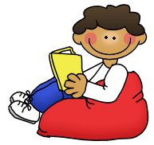


Maths Games
Every week, your child will bring a Maths game home for you to play together to support their maths learning in a fun way. Please complete the form accompanying the game to tell us how your child got on. Please return these each week.


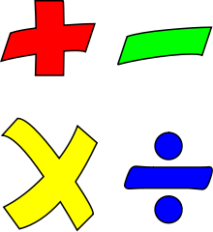


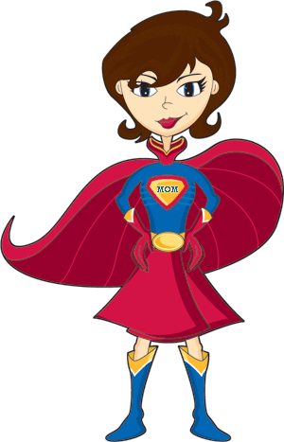
Homework and Super Hero Spelling Zappers

Once your child has settled back into school, they will bring home weekly homework. The homework will be in the book bags on Fridays and should be returned the following Wednesday. Homework can also be accessed through the VLE. It will contain a Maths activity (set weekly), practice of multiplication tables (2, 3, 4, 5 and 10), and a Topic activity (set bi-weekly) for you to do with your child which builds on their learning in school. Homework activities should take up to 15 minutes each. The homework letter will keep you informed of what is happening in the classroom and any special events that are taking place.
Your child will receive a Super Hero Zapper each week with their focus words for the week on them. Please help your child to learn these words at home.



